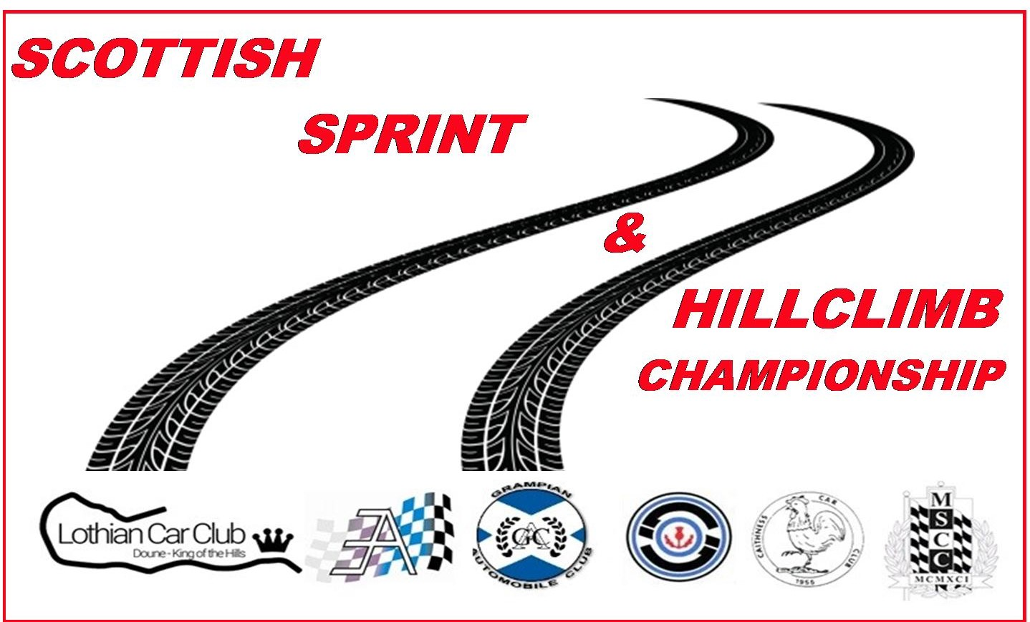
Scottish Sprint & Hillclimb Championship Club

Supplementary Regulations

Boyndie Sprint
16th / 17th August 2025

Scottish Sprint & Hillclimb Championship Club Ltd will organise a RS Interclub status sprint on
16th / 17th August 2025 at Grampian Kart Club, Boyndie by Banff.
This event will use circuit 1 layout, which is a tarmacadam surface, 825m long and consist of 1.8 laps.

- The event will be held under the National Competition Rules of Motorsport UK (incorporating the provisions of the International Sporting Code of the FIA), these Supplementary regulations, and the Scottish Sprint & Hillclimb Championship Regulations, and any other written instructions issued by the Club.

- A MSUK Permit has been applied for

- The event is open to all fully elected members of the organising club, and members of Clubs which are affiliated to the Scottish Association of Car Clubs.

- All competitors must produce a valid competition licence, club membership card and the appropriate vehicle documentation.
The club would like to remind all potential entrants that a R.S Interclub is the minimum licence requirement subject to MSUK requirements for Racing, Sports & Saloon Libre cars. Physical Checks on licences will be carried out

- The event will count as two rounds of the 2025 Scottish Sprint Championship, one round of the 2025 Scottish Speed Championship & two rounds 2025 Blackadder’s Highland Speed Championship, Other championship may be included, these will be announced with the final instructions

- Event Officials:
Motorsport UK Steward – TBA Event Secretary – Graeme Webster
Club Stewards - TBA Chief Scrutineer - Alison Mitchell
Clerk of the Course - TBA Chief Marshal - TBA
Chief Timekeeper - Jim Reid Safeguard Officer – Fiona Webster
Assist Timekeeper - Lorna Renshaw Chief Medical Officer – Keith Jenson / Ewan Littlejohn

Entries may be made on the Rallyscore website using the link https://.www.rallyscore.net (Alternatively, go to the Rallyscore website at www.rallyscore.net and on the Home page, scroll down to the list of events and select ”Boyndie Sprint

First Car will Start 09.00hrs on each day of competition

- Any competitor not signed on by 09.00hrs may be disqualified from the event.

- The events will consist of the 25 classes below;

Division J – Standard Road Car

Class Description
J1 Drivers aged 14 to 16 in Cars
of 110bhp

Division A Road Cars

Class | Description
A1 | Road Saloon Cars up to 1400cc
A2 | Road Saloon Cars over 1400cc & up to 2000cc
A3 | Road Saloon Cars over 2000cc
A4 | Road Sports Cars up to 1400cc
A5 | Road Sports Cars over 1400cc & Up to 1700cc
A6 | Road Sports Cars over 1700cc
A8 | Marque Road Sports Cars
A9 | Scottish MX5 Hillclimb and Sprint Register Cars
Division B Modified Cars
B1 | Modified Saloon Cars up to 1400cc
B2 | Modified Saloon Cars over 1400cc & up to 2000cc
B3 | Modified Saloon Cars over 2000cc
B4 | Modified Sports Cars up to 1400cc
B5 | Modified Sports Cars over 1400cc & up to 1700cc
B6 | Modified Sports Cars over 1700cc

Division C Competition Cars

C0 | Saloon Libre
C1 | Sports Libre Cars up to 1400cc
C2 | Sports Libre Cars over 1400cc & up to 1800cc
C3 | Sports Libre Cars over 1800cc
C4 | Racing Cars up to 1100cc
C5 | Racing Cars over 1100cc & up to 1600cc
C6 | Racing Cars over 1600cc
Division D - Classic and Thoroughbred Cars (Period defined)

D1 | Classic and Thoroughbred Road Cars
D2 | Classic and Thoroughbred Modified Cars
D3 | Classic and Thoroughbred Competition Cars

11. Competitors will start singly. The Method of Timing will be electronic, and the start signal will be a green light.
The finish line will be indicated by a chequered flag.

12. Competition cars will be identified with competition numbers.
It is the responsibility of the competitor to ensure that their car is numbered appropriately. NCR 14.2.3 Refers

13. On each day, competitors will have the opportunity to practice (in accordance with NCR 14.5.2) followed by the minimum
Two Timed runs.
Competitors must walk the course prior to commencement of practice runs.

14. Awards for the event will be presented as follows:
Fastest Time of Day
Class Awards
1st in Class
2ndin Class (where there are more than 5 or more competitors in a class)
3rd in Class (where there are more than 10 competitors in a class)
4th in Class (where there are more than 15 competitors in a class)
The above awards will be presented at the conclusion of the meeting each day

15. Provisional Results will be available on resultsman.co.uk

16. The maximum entry for the meeting is 70 and the minimum is 40.
The Organisers reserve the right to amalgamate classes if necessary and reserve the right to cancel the meeting should
Minimum numbers not be met
17. Entries for the August Event will open on the 14th of July 2025 and close on the 10th of August 2025.

Late entries will not be accepted

18. The entry fee for the event is £190 for the weekend. Entry fee for one day is £100.

19. Any Competitor withdrawing from an event less than 7 days before the start of the event may be subject to an administration fee of £50

Any competitor who fails to notify the Club of their non-attendance will forfeit their entry fee

20. Flag signals will be in accordance with NCR 14 7.1B

21. Any protest must be lodged in accordance with NCR 2 9 1, accompanied by the appropriate protest fee.

22. A Timing Strut in accordance with NCR 14.4 11.1 is required.
Checks may be carried out in accordance with NCR 3 11 Chapter 5 Part A App 11 1,2,3,4,5,6 and NCR 2 Art.2, Chapter 5 App.11 Art.1.6, Chapter 3 Art.17 regarding the use of alcohol and/or drugs.

23. Tyre Warming is banned at Boyndie circuit

24. Competitors must note that any competitor-recorded videos are the property of the MSUK and may have to be
surrendered as required by MSUK's rules.

25. NO Dogs are allowed in the paddock during the event.

26. NO Single Use Tyre wrap to be used at Boyndie, the Use of Reusable Tyre Covers is Permitted

27. NO trailers will be permitted to move in the Paddock until the end of the event on both days, Failure to comply with this
request may result in the Forfeit of any Championship points gained during the event.

28. Paddock spaces will be allocated by Class, Spaces will be numbered and Drivers are requested to use their allocated space, This is a Health and Safety requirement, Failure to comply will result in Expulsion from the Event.

29.

Race With Respect

Encouraging a positive environment, on and off the track

A socially-minded standard of behaviour is expected from everyone within the motorsport community. By participating in a Motorsport UK event, in any capacity, you are agreeing to follow the values of the governing body’s Respect Code:

Respect Integrity Fair Play Self-control Good Manners
We therefore ask all members to pledge to
#RaceWithRespect
Contribute to a welcoming and friendly environment that ensures the safety and welfare of all participants
Always behave with integrity and uphold fairness in the sport; play your part in keeping the sport safe through your actions
Treat everyone with respect, regardless of their gender, ethics or social background, language, religious or other beliefs, disability, sexual identity or other status
Recognise that we all represent the sport and therefore have a duty to be polite and respectful to all staff, officials, competitors, volunteers, as well as fans and supporters
Respect the rules, regulations and authority of the officials and Motorsport UK
Breaching any of the above obligations may result in disciplinary action END OF SUPPLIMENTARY REGULATIONS

